**MACHINE LEARNING AND DEEP LEARNING INTERNSHIP**

**Project Report**

Project ID:

**Project Title:**

**Pneumonia Prediction using X-RAY images**

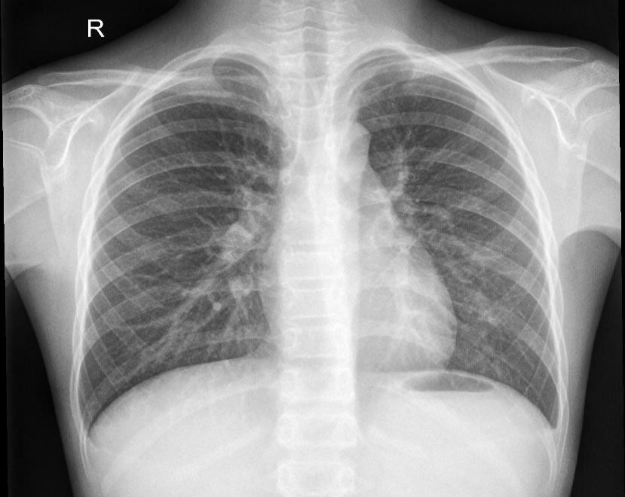

**Team members:**

**Ishani N Binu, Sheethal Krishna, Vishnu Priya,**

**Dinesh D, Manav Jain**

**INDEX**

**1.Introduction**

1. Overview
2. Purpose

**2.Literature Survey**

**3.Theoretical Analysis**

1. Block diagram
2. Hardware/Software designing

**4.Experimental Investigations**

**5.Flowchart**

**6.Result**

**7.Advantages and Disadvantages**

**8.Applications**

**9.Conclusions**

**10.Future Scope**

**11.Biblilography**

**12.Appendix**

**1.INTRODUCTION**

A. Overview

Pneumonia is an intense respiratory disease that influences the lungs. It is a lethal disease wherein the air sacs get loaded up with discharge and other fluid. Pneumonia is ranked eighth in the list of the top 10 causes of death in the United States. Pneumonia causes the passing of around 700,000 youngsters consistently and influences 7% of the worldwide populace. Chest X-rays are fundamentally utilized for the conclusion of this infection. Computer-aided diagnosis using artificial intelligence-based solutions is becoming increasingly popular these days. An issue with this illness is that occasionally, the highlights that depict the actual presence of the sickness regularly get blended in with different infections, and thus, radiologists think that it's difficult to analyse this illness. Deep learning techniques take care of this load of issues, and their exactness in the forecast of the infection is something very similar and, in some cases, considerably more prominent than a normal radiologist. Among the profound learning procedures, convolutional neural networks (CNNs) have shown extraordinary guarantee in picture grouping and division and hence are generally embraced by the exploration local area. Biomedical diagnosis that utilizes deep learning and computer vision has demonstrated to be extremely useful to give a speedy and exact conclusion of the illness that coordinates with the precision of a dependable radiologist.

B. Purpose

This project is about building a web application that can determine a patient to have pneumonia effectively by breaking down its X-ray picture. A productive model for the recognition of pneumonia prepared on advanced chest X-ray pictures is proposed, which could help the radiologists in their dynamic interaction. An original methodology dependent on a weighted classifier is presented, which consolidates the weighted expectations from the cutting-edge profound learning models like ResNet18, Exception, InceptionV3, DenseNet121, and MobileNetV3 in an ideal way. This methodology is a regulated learning approach in which the organization predicts the outcome dependent on the nature of the dataset utilized. The proposed methodology uses a deep transfer learning algorithm that extracts the features from the X-ray image that describes the presence of disease automatically and reports whether it is a case of pneumonia.

2.LITERATURE SURVEY

Research Paper 1

Okeke Stephen, Mangal Sain, Uchenna, and Do-Un Jeong proposed a convolutional neural network model trained from scratch to classify and detect the presence of pneumonia from a collection of chest X-ray image samples. Unlike other strategies that depend entirely on transfer learning draws near or conventional handmade strategies to accomplish a wonderful arrangement performance, they built a convolutional neural network model from scratch to extract features from a given chest X-beam picture and group it to decide whether an individual is tainted with pneumonia. This model could help moderate the dependability and interpretability challenges regularly confronted when managing medical imagery.

Research Paper 2

By Daniel S Kermany, Michael Goldbaum, Wenjia paper, here, it established a diagnostic tool based on a deep-learning framework for the screening of patients with common treatable blinding retinal diseases. The exhibition of model relies exceptionally upon the loads of the pre-trained model. Subsequently, the presentation of this model would probably be upgraded when tried on a bigger ImageNet dataset with further developed deep-learning techniques and architecture.

Research Paper 3

The proposed paper presents a deep neural network based on convolutional neural networks and residual network along with techniques of identifying optimum differential rates using cosine annealing and stochastic gradient with restarts to achieve an efficient and highly accurate network which will help detect and predict the presence of pneumonia using chest x-rays.

3.THEORITICAL ANALYSIS

A. Block Diagram

The following is the block diagram of our proposed solution of using the Convolution Neural Networks (CNN) to analyse the images of the X-ray to predict whether the pneumonia is present or not.

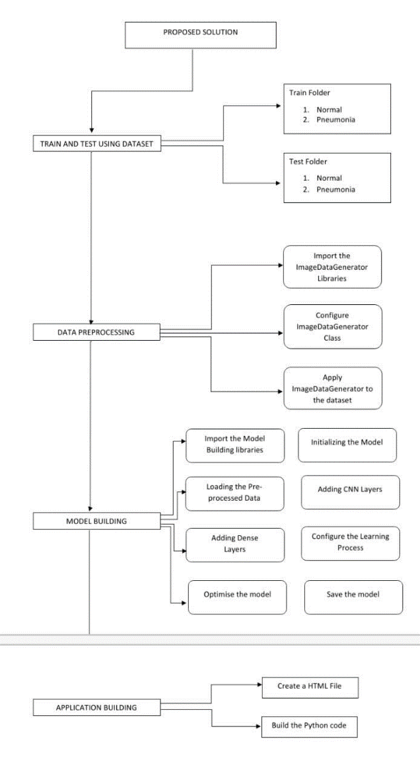

B. Hardware software designing

Hardware requirements: Laptop

Software requirements: Python-3.6, Keras, TensorFlow, Jupyter Notebook

4.EXPERIMENTAL INVESTIGATION

The dataset comprised a total of 5856 images and divided into two main parts, the training dataset testing dataset, validation dataset. Bacterial and viral were considered as one category i.e., pneumonia infected. Finally, there were 5216 images in the training dataset, 624 images in the testing dataset, 16 images in the validation dataset. The below figure shows the chest X-ray images of a healthy person and the other of a person suffering from pneumonia.

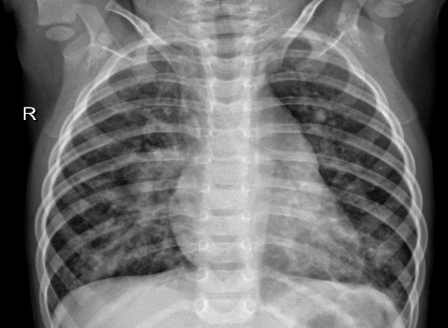

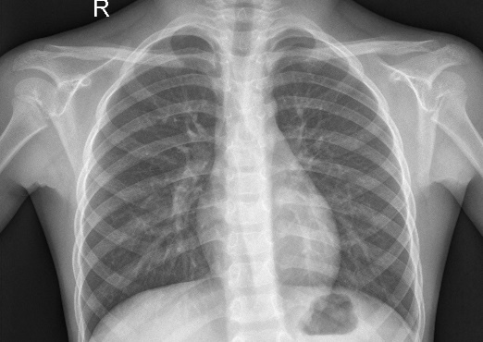

NORMAL PNEUMONIA

TABLE 1

Description of experimental dataset.

|  |  |  |  |
| --- | --- | --- | --- |
| CATEGORY | TRAINING SET | TESTING SET | VALIDATION SET |
| Normal | 1341 | 234 | 8 |
| Pneumonia | 3875 | 390 | 8 |
| Total | 5216 | 624 | 16 |
| Percentage | 89.07 | 10.65 | 0.27 |

5.FLOWCHART

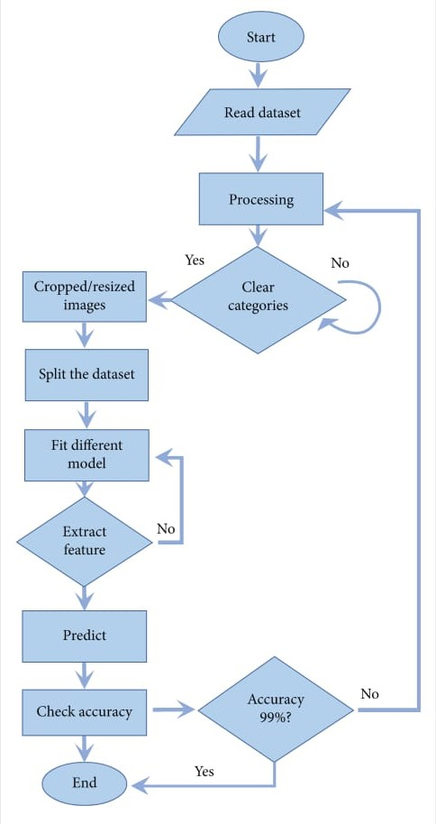

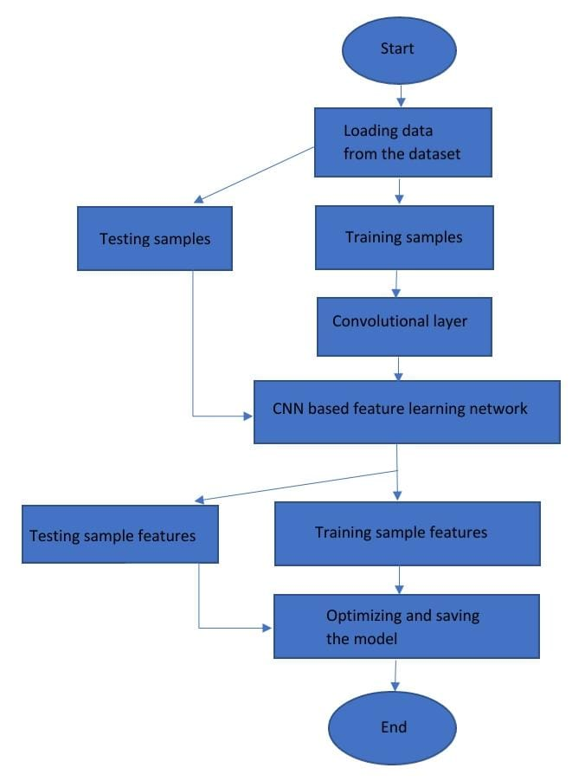

6.RESULT

The following show the screenshots of our application of Pneumonia prediction using X-RAY images.

Home Page :

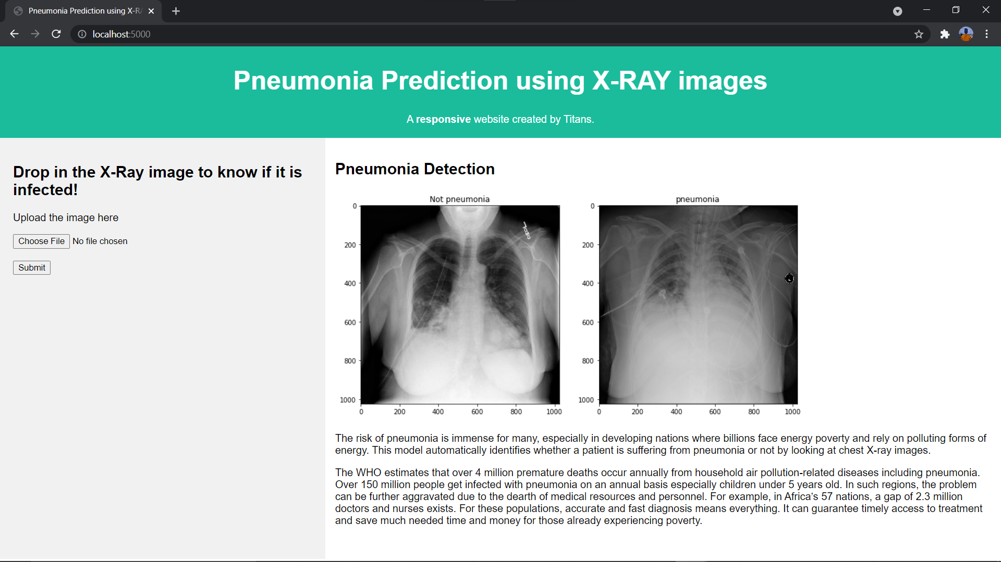

Prediction Page:

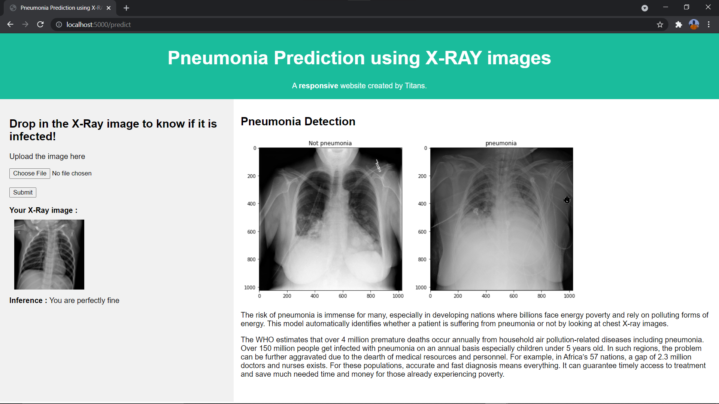

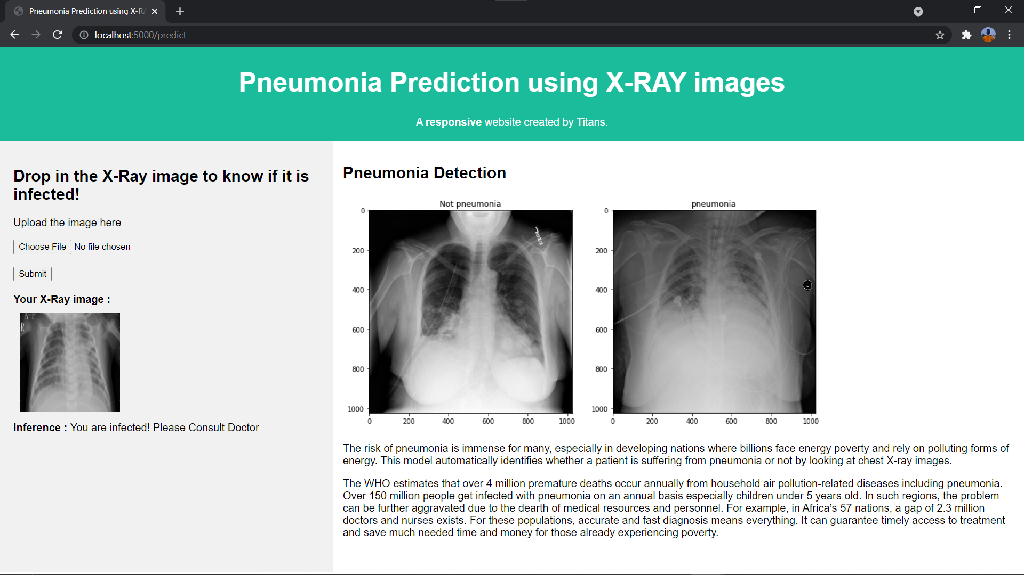

7. ADVANTAGES AND DISADVANTAGES

|  |  |
| --- | --- |
| ADVANTAGES | DISADVANTAGES |
| Easy model building with less formal statistical knowledge required. | Clinical interpretations of model parameters are difficult. |
| Capable of capturing interactions between predictors. | Sharing an existing ANN model is difficult. |
| Capable of capturing non linearities between predictors and outcomes. | Prone to overfitting due to the complexity of model structure. |

8.APPLICATIONS

The analysis of X-RAYS using CNN is right now being utilized at different clinical establishments including Singapore’s Changi General hospital (desktop application i.e., installed on radiology workstations) etc...

The application of CNN in Pneumonia detection using X-RAYS assists us with using different libraries present to help identify the severity of pneumonia that correlates to the degree of Chest X-RAY (CXR) lung image abnormality.

9.CONCLUSION

The following is the conclusion of our project:

Unsolved problem that is as of now tormenting the doctors around the world. Our proposed model is designed and advancement to detect and classify pneumonia from chest X-ray pictures. It contains both image processing and convolutional neural network. We developed a model; the algorithm starts by transforming chest X-ray images into sizes less than the original.

The next step includes the identiﬁcation and classiﬁcation of pictures by the convectional neural network structure, which extracts features from the image and classify them. This work has presented the X-Ray images for Pneumonia discovery based on convolutional neural networks and diverse machine learning. By training a bunch of solid CNNs for an enormous scope dataset, we built a model that can precisely predict Pneumonia. During each epoch data is trained again and again to learn the feature of data. The presentation assessment of the model is estimated by utilizing classiﬁcation accuracy and cross-validation.

10.FUTURE SCOPE

Pneumonia comprises a significant cause of morbidity and mortality. It represents an impressive number of grown-up emergency clinic affirmations, and countless those patients ultimately die. According to the WHO, pneumonia can be prevented with a simple intervention and early diagnosis and treatment. Nevertheless, most of the worldwide population needs admittance to radiology diagnostics. In any event, when there is the accessibility of imaging hardware, there is a lack of specialists who can analyse X-rays. It is no doubt that the predictive model can be worked on far superior by performing data augmentation or carrying out transfer learning concept which works with the model an opportunity to get better. Along these lines, this will be added as additional upgrade in the forthcoming stories. In the future, it is intriguing to see approaches in which the weights relating to various models can be assessed all the more proficiently and a model that considers the patient's set of experiences while making predictions.

11.BIBLIOGRAPHY:

1. Pneumonia. [(accessed on 31 December 2019)]; Available online: <https://www.radiologyinfo.org/en/info.cfm?pg=pneumonia>.
2. Johns Hopkins Medicine Pneumonia. [(accessed on 31 December 2019)]; Available online: <https://www.hopkinsmedicine.org/health/conditions-and-diseases/pneumonia>.
3. https://www.hindawi.com/journals/mpe/2021/9929274/

12. APPENDIX:

The following are the abbreviations used:

1. AI-Artificial Intelligence
2. CNN-Convolutional Neural Networks
3. WHO-World Health Organization